**An Imagine & Create Your Own World Book™**

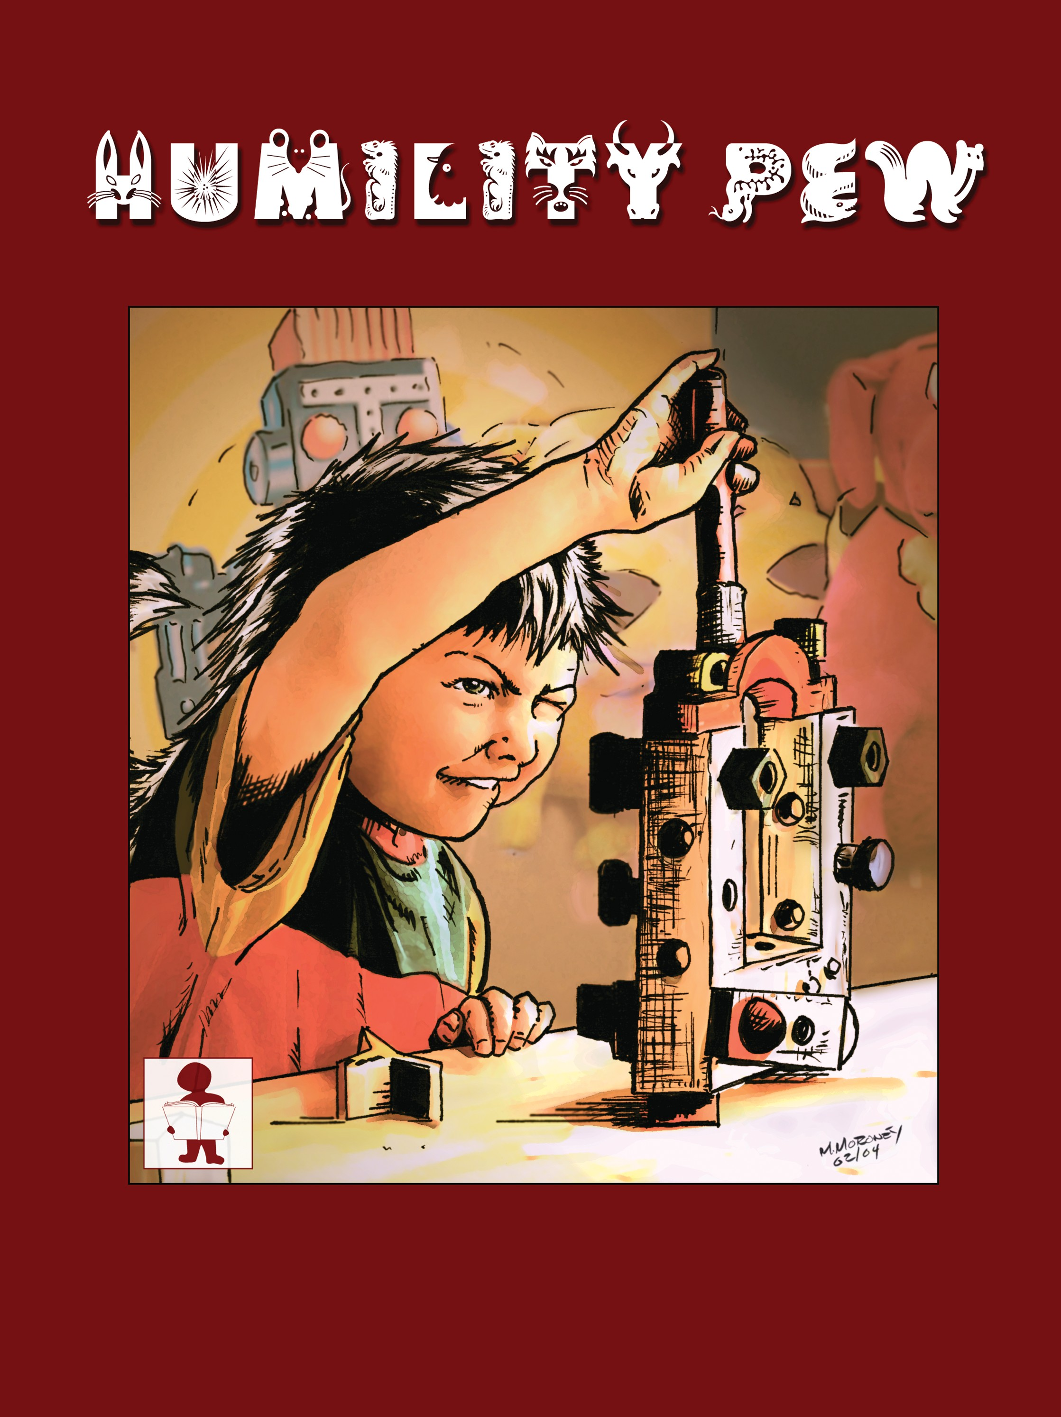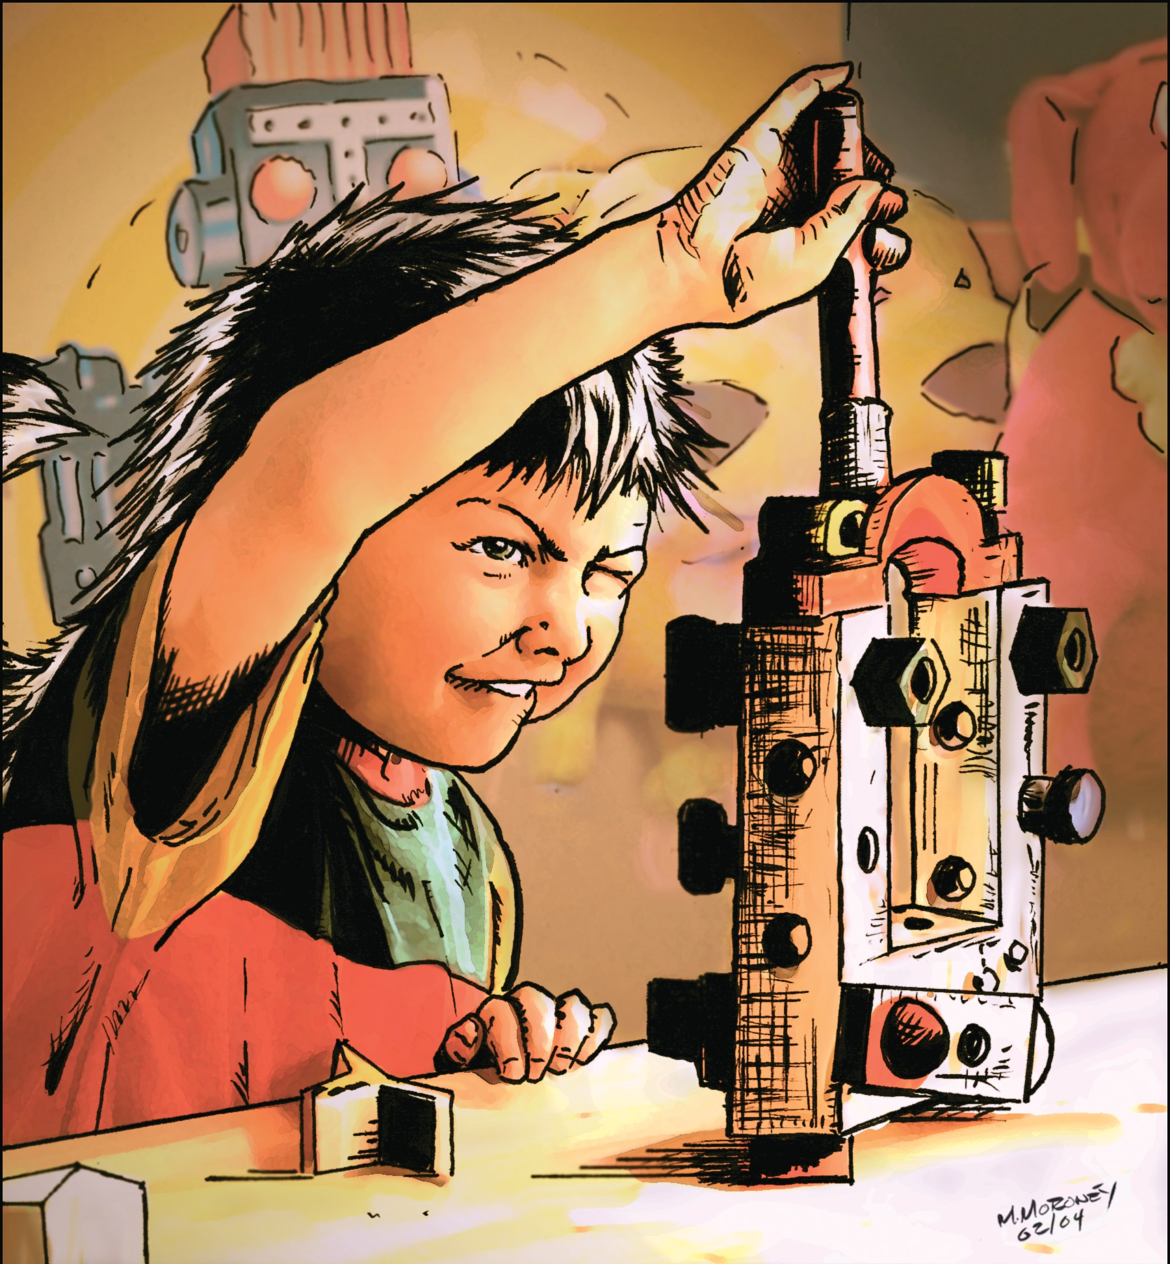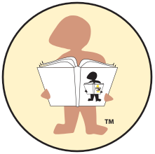

Book I

— Created by —

Linda Redford

**Part of the Honor Series of Edutainment Tools™**

To the Owner of this Book:

**As you read this story, look for clues that will help you answer these questions.**

★ What animal does Humility Pew look like in the beginning of the story?

This is a reminder that we are connected to the animal world and that animals have feelings too.

★ What instrument does Humility Pew play?

★ Does Humility Pew have a handicap? Remember there are physical handicaps like being blind or having one leg shorter than the other, and there are attitude handicaps such as selfishness and jealousy.

★ What does Humility Pew receive from Ageyya?

★ What does Catoosa give to Humility Pew?

★ What is the principle Humility Pew learns to express in the story?

★ What does Humility Pew turn into after learning to express this principle?

★ Research and find the original native peoples who lived on the land where the story takes place.

★ What happened to these original peoples?

★ We invite you to create your own Adawee Tribe and stories for your family, friends and school.

Hint l: **A clue to where the story takes place is in the phrase “As you share of your land of the free and the brave.” This language often refers to the land the story takes place in.**

Hint 2: **The principle Humility Pew learns is in his new name.**

Hint 3: **The original peoples who lived on this land still do.**

“Osada” in Tsalagi (Cherokee) means “It is good”.

Ageyya and Catoosa

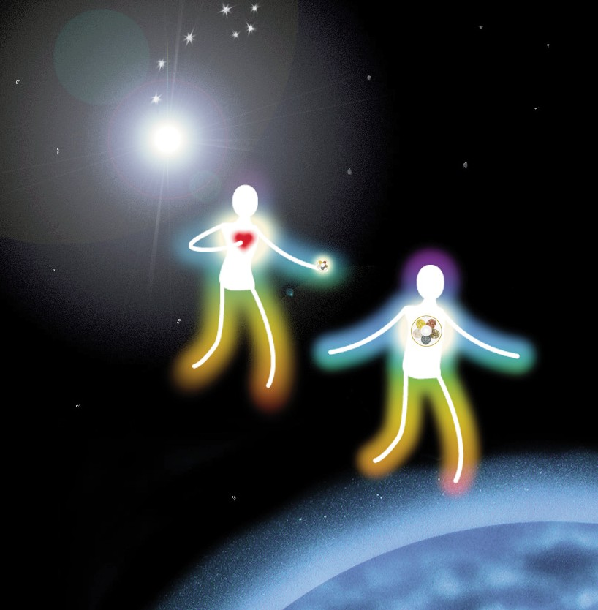

Ageyya descended from the Heavens above.

Ageyya was made of kindness and love. She came here to show us just how to care, By guiding us all in a new way — to share.

Catoosa descended to fulfill his part

After Ageyya had touched everyone’s heart.

He says, “Along with love, goes honor and pride, Respect for all people of the Adawee Tribe.”

And this little book will show how it’s done.

A book for all children under the sun. Ageyya hopes these stories will be helpful to you. Come along with the Tribe and Humility Pew.

Who is this Tribe and Humility Pew? Ageyya will now introduce one to you.

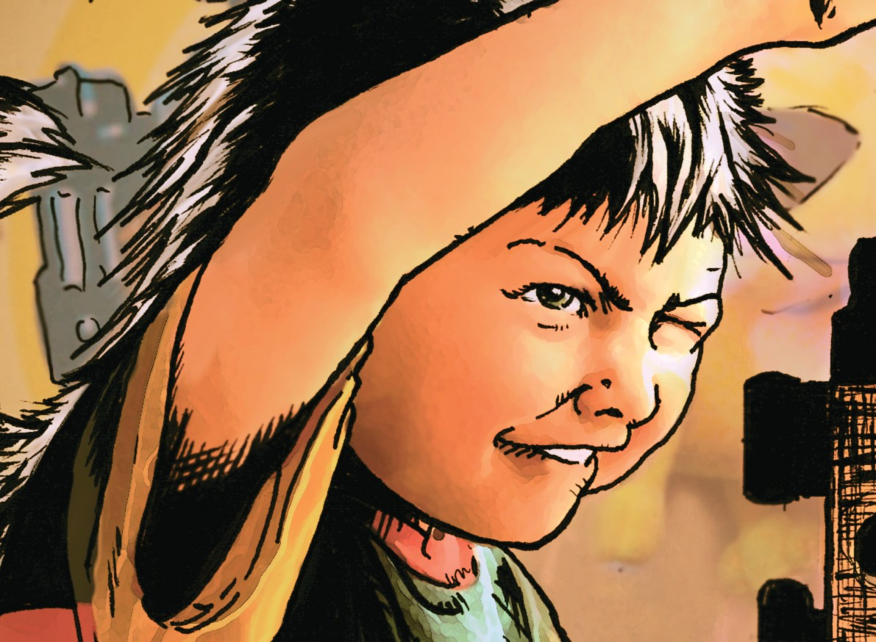

Humility Pew

(This poem is an adaptation of a poem from an anonymous author.)

A meeting was held quite far from Earth.

”It’s time again for another birth,” Said the Caregivers to the Spirit above. “Humility Pew will need much love.”

His progress may seem very slow. Accomplishments he may not show. And he’ll require extra care.

From the folks he meets down there.

He may not run or laugh or play.

His thoughts may seem quite far away.

In many ways he won’t adapt, And he’ll be known as handicapped.

So let’s be careful where he’s sent, We want his life to be content.

“Please, Great Spirit, find guardians who

Will do a special job for you.”

They will not realize right away

The leading role they’re about to play.

But with this child sent from above

Comes stronger faith and richer love.

This precious child we describe

Is one of Galunlati’s Adawee Tribe.

**Remember always: Handicaps come in all disguises. Some you can see with your eyes,**

**others you’ll have to feel with your heart. (HP is part skunk and part boy** 3

**in the beginning of the story and he plays the harmonica.)**

This Tribe member was once a real stinker, A spoiled skunk, not much of a thinker.

And he owned every toy that could possibly be.

And his name back then was simply HP.

His room was so cluttered with toys and clothes, You couldn’t clean it out with a water hose. When he tired of a toy, he’d toss it in the air.

Didn’t matter where it landed, he didn’t much care.

And he treated his friends as mean as could be. Made smart remarks, said “you wish you were me?” “I don’t need you,” he told everyone.

“The best thing of all is me having fun.”

Well, HP’s dad was a gambling man. Sometimes his bets got him into a jam.

So he took out a loan on his house for a horse, One that would race and win, of course.

But it didn’t, and the horse came up lame.

His dad lost everything to his name.

The beautiful house, and all the things that he had.

HP watched them go. BOY! Was he mad!

“No toys. No clothes. No car to drive.

Why on earth am I still alive?

I don’t want to live like this anymore!”

Then he threw a tantrum right there on the floor.

As time went on, HP couldn’t sleep.

He wandered about like a little lost sheep.

His elegant clothes were now tattered and torn. His shoes were run down, beat up, and worn.

That skunk had no scent much less a buck, No question, HP was down on his luck.

He hid from his friends, the kids having fun.

If they called him to play, how fast he would run!

He cried, “Why! Oh! Why did this happen to me? Now what in the world is my life going to be? Well, I’ll show them!” And this time he’d go

To the woods and a stream, a place no one would know.

Then Ageyya appeared and said with a smile, “I think I can help, if you’ll listen awhile.” She came out of the sun, just out of the sky, To touch HP’s heart, and his world nearby.

“You want me to listen? I got nothing to lose.

I got holes in my britches, and holes in my shoes.” Ageyya replied, “If you want to stand tall,

help someone else when you’re feeling small.”

“Help someone else?” thought HP, “Somebody else instead of me?“

Ageyya continued, “Look around and you’ll find that you can help creatures of every kind.”

For helping others who are doing without, Makes you feel good! You’ll want to shout! You’ll help yourself by helping a friend, And you will feel better in the end.”

“Gosh,” thought HP, as he plodded along, “It just might work, I could’ve been wrong.”

Then Ageyya touched him, not there on his tears,

She reached out and touched him, right there on his ears.

Suddenly the thunder roared and the lighting flashed!

The wind blew the trees and down one crashed!

And a voice from that tree, “Save my eggs!” it did scream. “Can you hear? Save my eggs! They’ll fall into the stream!”

HP spotted the nest in the tree once high, Then looked at the river rushing by.

Then a limb broke off and down fell the nest

And HP’s heart jumped hard in his chest.

So quickly he leaped with a neat, clean splash.

Right into the water like a lightning flash. He swam to the nest with all of his might,

Caught the sinking eggs, now almost out of sight.

His hair covered them over like a little skunkboat, As he swam to the mother like a motorboat. And about this time, out came the sun

And HP heard a peep, then another one.

There in the nest so tiny and small, HP saw the most beautiful sight of all. Smiles on the beaks of new baby birds, Filled his heart with love beyond words.

As the tiny birds sang, HP couldn’t hide

The feeling of joy for saving their lives.

In a burst of light The Star Gate came through carrying Ageyya and Catoosa too.

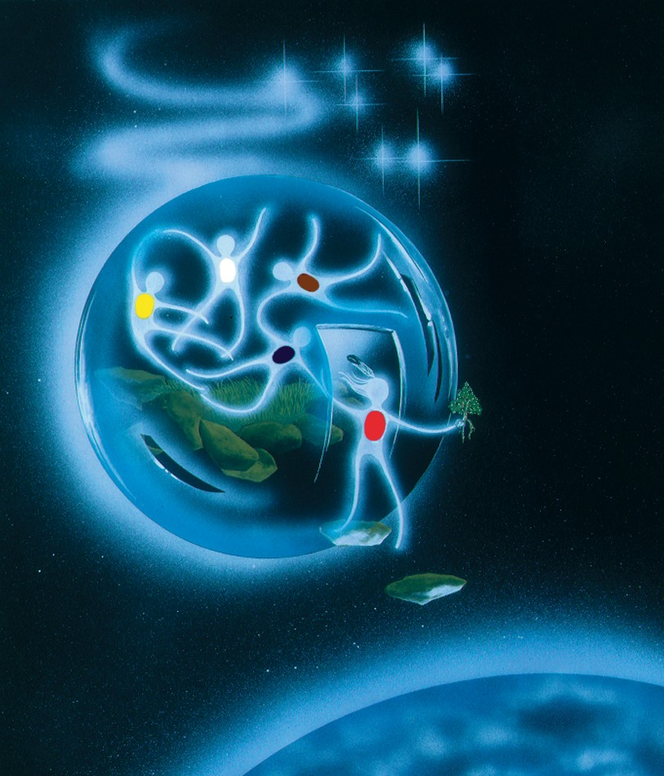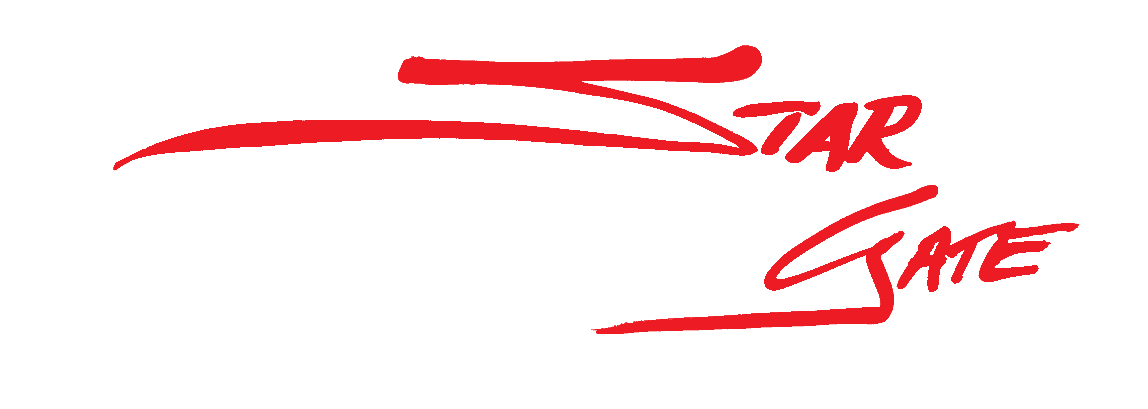

“Spoiled skunk,” he smiled, “no longer fits you, I give you your new name – Humility Pew. Wear it with honor and always be true

to the wonderful person inside of you.”

“And because you cared and helped someone new, Sparkle-Magic,” Ageyya smiled, “is my special gift to you.” It’s a Higher Power that comes from above.

It will shine through your eyes, it’s a power called LOVE.”

9

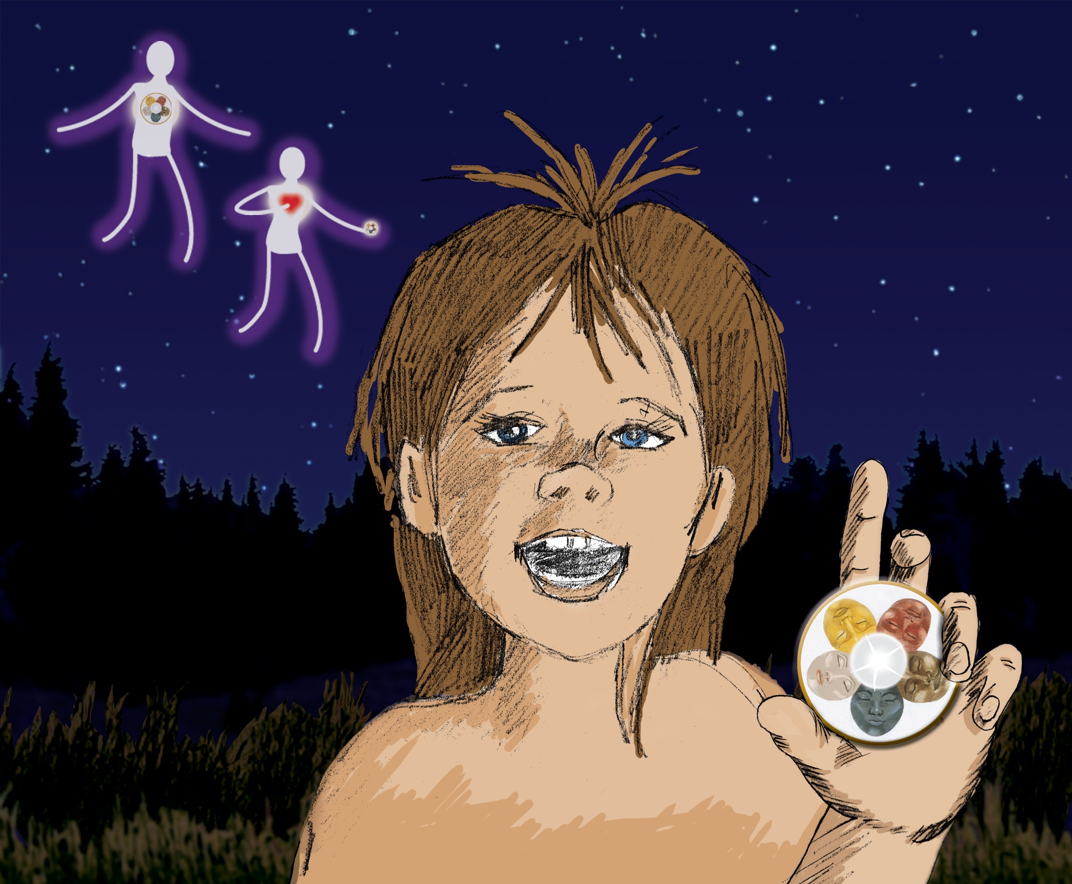

As the Star Gate rose to its home in the skies, The love she described stayed in Humility’s eyes. It was the safest feeling he had ever known,

That with love in his heart, he’d be never alone.

Never alone? And the Star Gate was gone.

Even so, her words lingered on.

“Never ever forget the pure heart that you gave,

As you share of your land of the free and the brave.”

If the stories from the heart really work for you, You’ll make a new friend in the Tribe’s Book Two.

**Humility Pew finds an Honor Medallion on the ground where the Star Gate had been. Attached**

**to the Medallion is a note. It reads: “You have learned how to be a planetary citizen of Mother Earth.”**

**Humility Pew is no longer part skunk; he now has the responsibility of being human.** 10

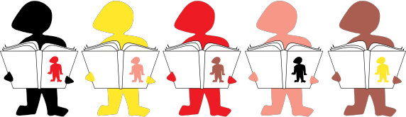

Ageyya, Ink. Publishers

Created by Linda Redford

Dedicated to Margaret Womack

Design by Judson Kramer and Linda Redford

Illustrated by Michael Moroney & Judson Kramer

© Copyright 2006. All rights reserved.

Adawee Pledge:

I HONOR myself;

I LIVE by principles that benefit future generations; I COMMUNICATE in a peaceful manner;

I RESPECT all cultures and honor our differences;

I ACKNOWLEDGE that males and females are equal in their importance;

I UNDERSTAND what I believe about myself and others creates my world;

I AM CONNECTED with all creation.

**We have a desire to create an “honorable” world.**

**Will you help us?**

**“Original” members of the Adawee Tribe:**

**Margaret, Harvey, Ashley, Anne, Johnny, Linda and Sparkle-Magic.**

Please join us!